DESIGN AND IMPLEMENTATION OF A DATABASE MANAGEMENT SYSTEM FOR ALUMNI MENTORING AND ENGAGEMENT MANAGEMENT SYSTEM
DBMS COURSE PROJECT REPORT

Submitted by
Name: K.Harshitha
Roll Number: 25WU0102134
Program: B.Tech.CSE- AIML (Panther)
Branch : .CSE- AIML (Panthers)
Year: II Year
Course: Database Management System
Course ID : 25TU03MJM0
Faculty Name: Kiranmayee Adavala
University: Woxsen University, Hyderabad
Academic Year: 2026–2027

1. Abstract
The Alumni Mentoring and Engagement Management System is a database management solution designed to organize alumni information, mentoring relationships, alumni engagement activities, events, registrations, and contributions in a structured relational database. The system provides a centralized way to store and retrieve alumni records and to connect alumni mentors with students who need guidance.
The proposed system uses a relational database model in which separate tables represent alumni, students, mentors, mentorships, events, event registrations, engagements, and donations. Primary keys uniquely identify records, while foreign keys maintain relationships between related entities. The design aims to reduce duplicate data, improve data consistency, and support efficient SQL queries.
A simple user interface can be connected to the database to demonstrate the required DBMS operations: insertion, deletion, and viewing of records. The report also demonstrates DDL and DML commands, representative queries, normalization up to Third Normal Form (3NF), test cases, and the overall implementation approach.

2. Introduction and Problem Statement

2.1 Introduction
Alumni are an important part of an academic institution because they can support students through mentoring, professional guidance, networking, events, and other forms of engagement. When alumni information is maintained in separate spreadsheets, messages, or disconnected records, it becomes difficult to identify mentors, track student–mentor relationships, maintain event participation, and retrieve reliable information.
A database-driven system can provide one structured location for these records. The Alumni Mentoring and Engagement Management System proposed in this report stores the main entities and their relationships in a relational database and provides operations for adding, viewing, updating, and deleting records.

2.2 Problem Statement
The problem is to design and implement a database management system for maintaining alumni information and supporting mentoring and engagement activities. The system should organize alumni and student records, maintain mentor assignments, record mentorship progress, manage alumni events and registrations, and track engagement and donations while preserving data integrity.

2.3 Existing System – General Limitations
- Alumni information may be distributed across multiple files or informal communication channels.
- Finding an appropriate mentor based on expertise can be difficult without structured data.
- Event participation and alumni engagement history may not be consistently recorded.
- Duplicate records and inconsistent updates can reduce data reliability.
- Generating reports or filtering records requires manual effort when data is not centralized.

2.4 Proposed System
The proposed system uses MySQL as the relational database layer and a simple application interface for database operations. The design separates data into related tables and uses primary and foreign keys to enforce relationships. The application can provide forms for insertion, deletion, and viewing, while SQL queries provide data retrieval and reporting capabilities.

3. Objectives and Scope

3.1 Objectives
- Create a centralized relational database for alumni and engagement information.
- Store alumni details such as contact information, graduation year, department, and current employment.
- Maintain student and mentor information and record mentorship relationships.
- Manage alumni events and event registrations.
- Record different forms of alumni engagement and contributions.
- Support insertion, deletion, and viewing of records through a user interface.
- Use primary keys, foreign keys, unique constraints, and suitable data types to maintain data integrity.
- Demonstrate DDL, DML, joins, aggregation, filtering, and other SQL operations.
- Reduce unnecessary data duplication through normalization.

3.2 Scope
The system covers the database management aspects of alumni mentoring and engagement. It includes alumni registration, mentor details, student–mentor relationships, event management, event participation, engagement history, and donations. The system can later be extended with authentication, notifications, recommendation features, dashboards, and analytics.

3.3 Users
USER | MAIN ACTIVITIES
Administrator | Manage alumni, mentors, students, events, registrations, and database records.
Coordinator | Create mentoring relationships, manage events, and monitor engagement.
Student | View suitable mentors and mentoring information.
Alumni / Mentor | Maintain professional information and participate in mentoring and events.

4. Software and Hardware Requirements

4.1 Software Requirements
COMPONENT | REFERENCE REQUIREMENT
Operating System | Windows 10/11 or equivalent
Database | MySQL 8.x or compatible MySQL server
Programming Language | Python 3.x for the reference UI
Database Connector | MySQL Connector/Python
User Interface | Python Tkinter or another simple GUI framework
Development Environment | VS Code / PyCharm / similar IDE
Documentation | Microsoft Word
Version Control | Git and GitHub

4.2 Hardware Requirements
COMPONENT | MINIMUM / RECOMMENDED
Processor | Dual-core processor or better
RAM | 4 GB minimum; 8 GB recommended
Storage | At least 5 GB free space for development tools and project files
Display | 1366 × 768 resolution or better
Network | Internet connection for GitHub repository operations

4.3 Functional Requirements
- The system shall allow alumni records to be inserted.
- The system shall allow records to be viewed and searched.
- The system shall allow authorized deletion of records.
- The system shall maintain student–mentor relationships.
- The system shall record event registrations and attendance status.
- The system shall maintain engagement and donation records.
- The database shall enforce key constraints and appropriate validation.

5. ER Diagram
The following conceptual ER diagram represents the reference database design prepared for this report. It identifies the major entities and shows how they are related. In the final submission, this figure should be replaced by the actual ER diagram used in Presentation-II if the student's implementation differs.
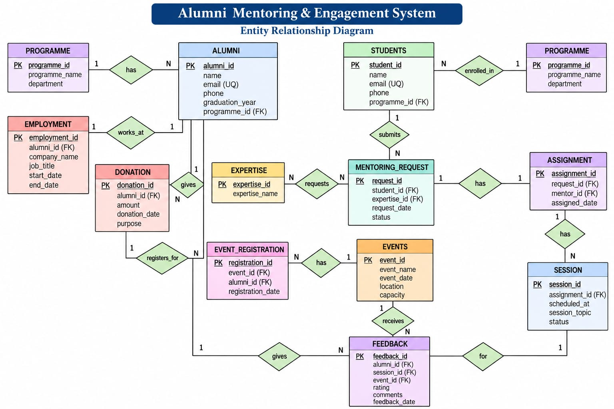
Figure 5.1: Conceptual ER diagram – reference implementation

5.1 Main Relationships
RELATIONSHIP | DESCRIPTION
Alumni – Mentor | An alumni member can be associated with mentor information.
Student – Mentorship | A student can have one or more mentorship records over time.
Mentor – Mentorship | A mentor can guide multiple students through mentorship records.
Alumni – Event Registration | An alumnus can register for multiple events.
Event – Event Registration | An event can have multiple alumni registrations.
Alumni – Engagement | An alumnus can have multiple engagement records.
Alumni – Donation | An alumnus can make multiple donation records.

6. Relational Schema and Normalization

6.1 Relational Schema
ALUMNI(AlumniID PK, Name, Email UQ, Phone, GraduationYear, Department, CurrentCompany, JobTitle, Location)
STUDENT(StudentID PK, Name, Email UQ, Program, GraduationYear)
MENTOR(MentorID PK, AlumniID FK, Expertise, Availability)
MENTORSHIP(MentorshipID PK, StudentID FK, MentorID FK, StartDate, EndDate, Status, Goals)
EVENT(EventID PK, EventName, EventDate, Venue, Description)
EVENT_REGISTRATION(RegistrationID PK, EventID FK, AlumniID FK, AttendanceStatus)
ENGAGEMENT(EngagementID PK, AlumniID FK, EngagementType, EngagementDate, Notes)
DONATION(DonationID PK, AlumniID FK, Amount, DonationDate, Purpose)

6.2 Normalization
Normalization is used to reduce redundant data and avoid update, insertion, and deletion anomalies. The reference design separates entities into individual tables and connects them using foreign keys.
NORMAL FORM | APPLICATION TO THE DESIGN
1NF | Each table contains atomic values; repeating groups are separated into related tables such as EVENT_REGISTRATION and MENTORSHIP.
2NF | Non-key attributes depend on the complete primary key. Relationship-specific attributes are kept in relationship tables.
3NF | Non-key attributes are stored with the entity they describe, reducing transitive dependencies between unrelated attributes.

6.3 Integrity Constraints
- Primary keys uniquely identify each record.
- Foreign keys maintain valid relationships between tables.
- UNIQUE constraints can prevent duplicate email addresses.
- NOT NULL constraints can be applied to mandatory attributes.
- CHECK constraints can be used for valid amounts or status values where supported.
- Referential actions should be selected carefully so that deleting a parent record does not unintentionally remove required historical information.

7. Data Dictionary
The following data dictionary describes the reference table structures. Data types and constraints should be adjusted if the student's actual SQL implementation uses different definitions.

ALUMNI
FIELD | DATA TYPE | CONSTRAINT | DESCRIPTION
AlumniID | INT | PK, AUTO_INCREMENT | Unique alumni identifier
Name | VARCHAR(100) | NOT NULL | Alumni full name
Email | VARCHAR(120) | UNIQUE, NOT NULL | Alumni email address
Phone | VARCHAR(20) | NULL | Contact number
GraduationYear | YEAR | NOT NULL | Year of graduation
Department | VARCHAR(80) | NOT NULL | Academic department
CurrentCompany | VARCHAR(120) | NULL | Current organization
JobTitle | VARCHAR(100) | NULL | Current job role
Location | VARCHAR(100) | NULL | Current city/location

STUDENT
FIELD | DATA TYPE | CONSTRAINT | DESCRIPTION
StudentID | INT | PK, AUTO_INCREMENT | Unique student identifier
Name | VARCHAR(100) | NOT NULL | Student name
Email | VARCHAR(120) | UNIQUE, NOT NULL | Student email
Program | VARCHAR(100) | NOT NULL | Programme or specialization
GraduationYear | YEAR | NULL | Expected/actual graduation year

MENTOR
FIELD | DATA TYPE | CONSTRAINT | DESCRIPTION
MentorID | INT | PK, AUTO_INCREMENT | Unique mentor identifier
AlumniID | INT | FK, NOT NULL | Associated alumni record
Expertise | VARCHAR(150) | NOT NULL | Mentor expertise area
Availability | VARCHAR(50) | NULL | General availability

MENTORSHIP
FIELD | DATA TYPE | CONSTRAINT | DESCRIPTION
MentorshipID | INT | PK, AUTO_INCREMENT | Unique mentorship identifier
StudentID | INT | FK, NOT NULL | Student receiving mentorship
MentorID | INT | FK, NOT NULL | Assigned mentor
StartDate | DATE | NOT NULL | Mentorship start date
EndDate | DATE | NULL | Mentorship end date
Status | VARCHAR(30) | NOT NULL | Active/completed/etc.
Goals | TEXT | NULL | Mentorship goals

EVENT
FIELD | DATA TYPE | CONSTRAINT | DESCRIPTION
EventID | INT | PK, AUTO_INCREMENT | Unique event identifier
EventName | VARCHAR(150) | NOT NULL | Event name
EventDate | DATE | NOT NULL | Event date
Venue | VARCHAR(150) | NULL | Event location
Description | TEXT | NULL | Event details

EVENT REGISTRATION
FIELD | DATA TYPE | CONSTRAINT | DESCRIPTION
RegistrationID | INT | PK, AUTO_INCREMENT | Unique registration identifier
EventID | INT | FK, NOT NULL | Registered event
AlumniID | INT | FK, NOT NULL | Registered alumnus
AttendanceStatus | VARCHAR(30) | NOT NULL | Registered/attended/absent

ENGAGEMENT
FIELD | DATA TYPE | CONSTRAINT | DESCRIPTION
EngagementID | INT | PK, AUTO_INCREMENT | Unique engagement identifier
AlumniID | INT | FK, NOT NULL | Associated alumnus
EngagementType | VARCHAR(80) | NOT NULL | Mentoring/event/talk/etc.
EngagementDate | DATE | NOT NULL | Date of engagement
Notes | TEXT | NULL | Additional details

DONATION
FIELD | DATA TYPE | CONSTRAINT | DESCRIPTION
DonationID | INT | PK, AUTO_INCREMENT | Unique donation identifier
AlumniID | INT | FK, NOT NULL | Donor alumni
Amount | DECIMAL(12,2) | NOT NULL | Donation amount
DonationDate | DATE | NOT NULL | Date of donation
Purpose | VARCHAR(150) | NULL | Donation purpose

8. SQL Commands Used (DDL and DML)

8.1 Database and Table Creation – DDL
CREATE DATABASE alumni_mentoring_db;
USE alumni_mentoring_db;

CREATE TABLE Alumni (
AlumniID INT PRIMARY KEY AUTO_INCREMENT,
Name VARCHAR(100) NOT NULL,
Email VARCHAR(120) UNIQUE NOT NULL,
Phone VARCHAR(20),
GraduationYear YEAR NOT NULL,
Department VARCHAR(80) NOT NULL,
CurrentCompany VARCHAR(120),
JobTitle VARCHAR(100),
Location VARCHAR(100)
);

CREATE TABLE Student (
StudentID INT PRIMARY KEY AUTO_INCREMENT,
Name VARCHAR(100) NOT NULL,
Email VARCHAR(120) UNIQUE NOT NULL,
Program VARCHAR(100) NOT NULL,
GraduationYear YEAR
);

CREATE TABLE Mentor (
MentorID INT PRIMARY KEY AUTO_INCREMENT,
AlumniID INT NOT NULL,
Expertise VARCHAR(150) NOT NULL,
Availability VARCHAR(50),
FOREIGN KEY (AlumniID) REFERENCES Alumni(AlumniID)
);

CREATE TABLE Mentorship (
MentorshipID INT PRIMARY KEY AUTO_INCREMENT,
StudentID INT NOT NULL,
MentorID INT NOT NULL,
StartDate DATE NOT NULL,
EndDate DATE,
Status VARCHAR(30) NOT NULL,
Goals TEXT,
FOREIGN KEY (StudentID) REFERENCES Student(StudentID),
FOREIGN KEY (MentorID) REFERENCES Mentor(MentorID)
);

8.2 Additional Tables – DDL
CREATE TABLE Event (
EventID INT PRIMARY KEY AUTO_INCREMENT,
EventName VARCHAR(150) NOT NULL,
EventDate DATE NOT NULL,
Venue VARCHAR(150),
Description TEXT
);

CREATE TABLE Event_Registration (
RegistrationID INT PRIMARY KEY AUTO_INCREMENT,
EventID INT NOT NULL,
AlumniID INT NOT NULL,
AttendanceStatus VARCHAR(30) NOT NULL,
FOREIGN KEY (EventID) REFERENCES Event(EventID),
FOREIGN KEY (AlumniID) REFERENCES Alumni(AlumniID)
);

CREATE TABLE Engagement (
EngagementID INT PRIMARY KEY AUTO_INCREMENT,
AlumniID INT NOT NULL,
EngagementType VARCHAR(80) NOT NULL,
EngagementDate DATE NOT NULL,
Notes TEXT,
FOREIGN KEY (AlumniID) REFERENCES Alumni(AlumniID)
);

CREATE TABLE Donation (
DonationID INT PRIMARY KEY AUTO_INCREMENT,
AlumniID INT NOT NULL,
Amount DECIMAL(12,2) NOT NULL,
DonationDate DATE NOT NULL,
Purpose VARCHAR(150)
);

8.3 Sample DML – INSERT
INSERT INTO Alumni
(Name, Email, Phone, GraduationYear, Department, CurrentCompany, JobTitle, Location)
VALUES
('Ananya Rao','ananya@example.com','9876543210',2022,'CSE',
'TechNova','Software Engineer','Hyderabad'),
('Rahul Mehta','rahul@example.com','9876501234',2021,'CSE',
'DataWorks','Data Analyst','Bengaluru');

INSERT INTO Student
(Name, Email, Program, GraduationYear)
VALUES
('Aarav Kumar','aarav@student.edu','B.Tech CSE-AIML',2027),
('Meera Shah','meera@student.edu','B.Tech CSE-AIML',2027);

INSERT INTO Mentor
(AlumniID, Expertise, Availability)
VALUES
(1,'Machine Learning','Weekends'),
(2,'Data Analytics','Evenings');

8.4 Sample DML – UPDATE and DELETE
UPDATE Alumni
SET CurrentCompany = 'TechNova Labs'
WHERE AlumniID = 1;

DELETE FROM Alumni
WHERE AlumniID = 2;
The DELETE command should be executed only after checking dependent records because foreign-key relationships may prevent deletion or may require an explicitly chosen referential action.

8.5 Sample Output
COMMAND | SAMPLE RESULT
CREATE DATABASE | Query OK
CREATE TABLE Alumni | Query OK
INSERT INTO Alumni | 2 rows inserted
INSERT INTO Student | 2 rows inserted
INSERT INTO Mentor | 2 rows inserted
UPDATE Alumni | 1 row updated

9. Queries with Outputs

9.1 View all alumni
SELECT AlumniID, Name, GraduationYear, Department, CurrentCompany
FROM Alumni;
AlumniID | Name | GraduationYear | Department | CurrentCompany
1 | Ananya Rao | 2022 | CSE | TechNova
2 | Rahul Mehta | 2021 | CSE | DataWorks

9.2 Find alumni working in a particular company
SELECT Name, CurrentCompany, JobTitle
FROM Alumni
WHERE CurrentCompany LIKE '%Tech%';
Name | CurrentCompany | JobTitle
Ananya Rao | TechNova | Software Engineer

9.3 List active mentorships
SELECT s.Name AS Student, a.Name AS Mentor, m.Status
FROM Mentorship m
JOIN Student s ON m.StudentID = s.StudentID
JOIN Mentor mt ON m.MentorID = mt.MentorID
JOIN Alumni a ON mt.AlumniID = a.AlumniID
WHERE m.Status = 'Active';
Student | Mentor | Status
Aarav Kumar | Ananya Rao | Active

9.4 Count alumni by graduation year
SELECT GraduationYear, COUNT(*) AS AlumniCount
FROM Alumni
GROUP BY GraduationYear
ORDER BY GraduationYear;
GraduationYear | AlumniCount
2021 | 1
2022 | 1

9.5 Presentation-II Assigned Query
The supplied instructions require the query given during Presentation-II to be included in the final report. The actual assigned query was not present in the supplied PDF. Paste the exact Presentation-II query and its actual output below before submission.
ITEM | TO BE REPLACED WITH ACTUAL PROJECT DATA
Assigned query | Paste the exact query given during Presentation-II.
Output | Paste the screenshot or result table produced by the actual database.
Explanation | Briefly explain what the query returns and why it is useful.

10. UI Design and Screenshots
The DBMS project instructions require a working UI connected to the MySQL database and a live demonstration of insertion, deletion, and viewing operations. They also require source code and screenshots of every UI screen, including before-and-after views.

10.1 Reference UI – Insert Record
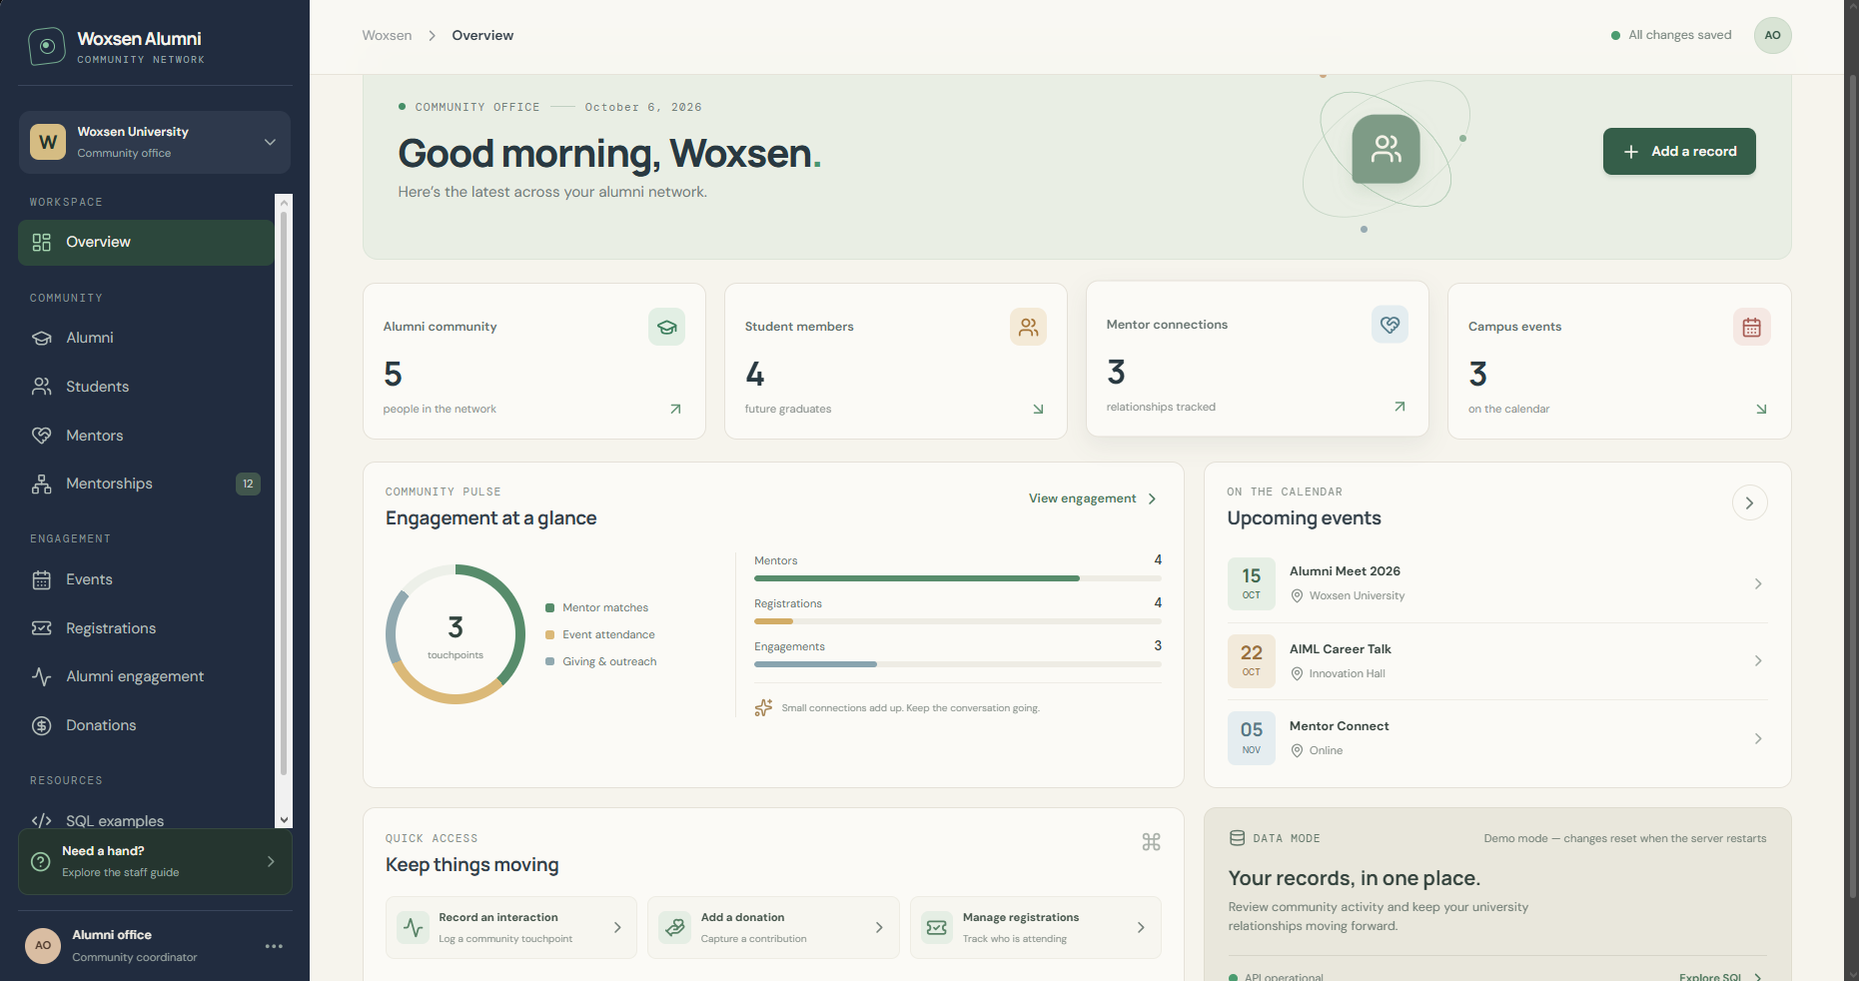
Figure 10.1: Illustrative alumni insertion screen – replace with actual project screenshot

10.2 Reference UI – View Records
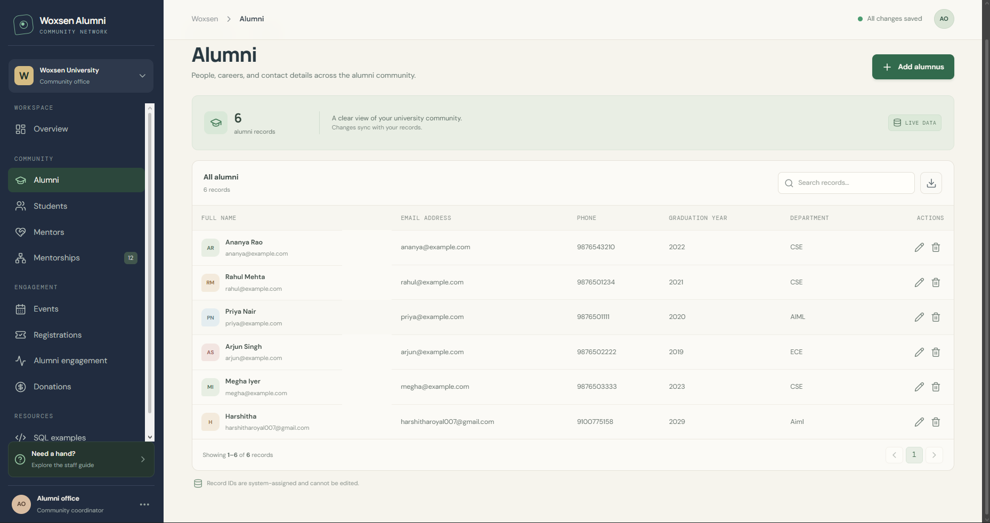
Figure 10.2: Illustrative record viewing screen – replace with actual project screenshot

10.3 Reference UI –Event Record
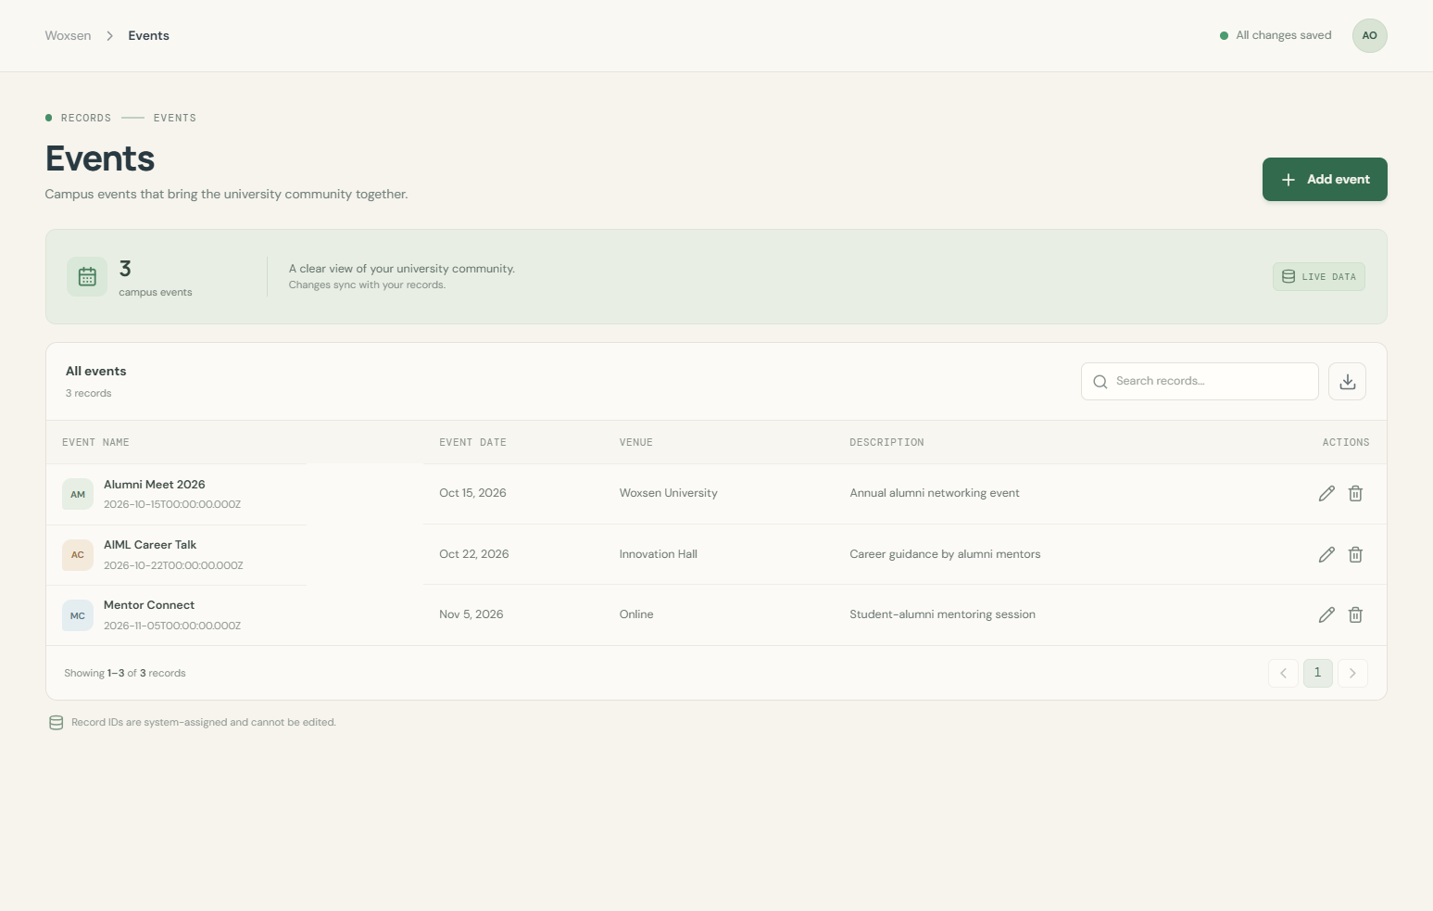
Figure 10.3: Illustrative deletion screen – replace with actual project screenshot

10.4 Reference UI – Mentorship Management
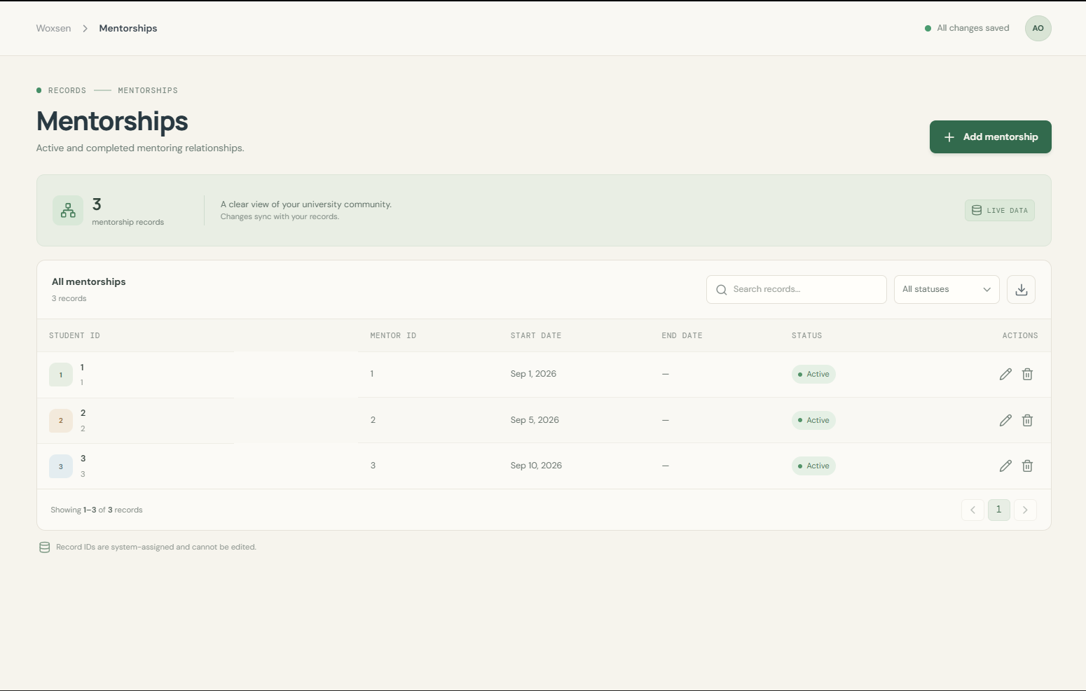
Figure 10.4: Illustrative mentorship management screen – replace with actual project screenshot

10.5 UI Operation Flow
- Open the application and establish a connection with the MySQL database.
- Select the required module, such as Alumni Management or Mentorship Management.
- Enter the required fields and submit the form.
- Execute the corresponding INSERT, DELETE, or SELECT operation.
- Refresh or reload the view to verify the database change.
- Capture before-and-after screenshots for the final report.

11. Implementation Details

11.1 Technology Stack
LAYER | REFERENCE TECHNOLOGY | PURPOSE
Database | MySQL | Store and manage relational data
Backend / Application | Python 3.x | Application logic and validation
Database Connectivity | MySQL Connector/Python | Connect application to MySQL
UI | Tkinter or equivalent GUI | Provide forms and record views
Development | VS Code / similar IDE | Write and test code
Version Control | Git + GitHub | Store project files and commit history

11.2 Database Connectivity – Key Code Snippet
import mysql.connector

connection = mysql.connector.connect(
host="localhost",
user="root",
password="YOUR_PASSWORD",
database="alumni_mentoring_db"
)

cursor = connection.cursor()
cursor.execute("SELECT AlumniID, Name, Email FROM Alumni")
records = cursor.fetchall()

for row in records:
print(row)

cursor.close()
connection.close()
For the actual project, the database password should not be hard-coded in a public GitHub repository. Use a secure configuration method and remove private credentials before uploading source code.

11.3 Insert Operation – Key Logic
sql = """INSERT INTO Alumni
(Name, Email, Phone, GraduationYear, Department)
VALUES (%s, %s, %s, %s, %s)"""

values = (name, email, phone, graduation_year, department)
cursor.execute(sql, values)
connection.commit()

11.4 Delete Operation – Key Logic
sql = "DELETE FROM Alumni WHERE AlumniID = %s"
cursor.execute(sql, (alumni_id,))
connection.commit()

11.5 View Operation – Key Logic
sql = "SELECT * FROM Alumni ORDER BY AlumniID"
cursor.execute(sql)
rows = cursor.fetchall()

12. Testing
Testing verifies that the database and interface perform the required operations correctly. The following test cases are a reference test plan and should be executed against the student's actual implementation.
TC ID | TEST CASE | INPUT / ACTION | EXPECTED RESULT | STATUS
TC01 | Insert alumni | Enter valid alumni details and click Insert | New record is stored and displayed | Pass*
TC02 | View alumni | Open View Records | Existing records are displayed | Pass*
TC03 | Delete alumni | Enter valid AlumniID and click Delete | Selected record is removed if constraints allow | Pass*
TC04 | Duplicate email | Insert an email already present | Database rejects duplicate due to UNIQUE constraint | Pass*
TC05 | Invalid required field | Leave Name blank and submit | Validation prevents insertion | Pass*
TC06 | Mentorship join | Create valid student/mentor relationship | Mentorship record is stored with valid foreign keys | Pass*
TC07 | Invalid foreign key | Use a non-existing MentorID | Database rejects the record | Pass*
TC08 | Event registration | Register alumni for an existing event | Registration record is created | Pass*
TC09 | Query filtering | Run company/department filter query | Only matching records are returned | Pass*
TC10 | Database connection | Start application with MySQL available | Connection succeeds and UI loads data | Pass*

* “Pass” here indicates the expected result of the reference test case. Replace the status with the actual result obtained during testing.

12.1 Testing Checklist for Presentation-III
- Show the application connected to the MySQL database.
- Insert a new record and show it in the database.
- Delete a record and show the change in the database.
- View records and demonstrate that the displayed data matches the database.
- Keep before-and-after screenshots for all required operations.

13. Conclusion and Future Enhancements

13.1 Conclusion
The Alumni Mentoring and Engagement Management System provides a structured relational approach for storing and managing alumni, students, mentors, mentorships, events, registrations, engagements, and donations. The proposed design uses primary and foreign keys to connect related records and normalization to reduce unnecessary duplication.
The system also demonstrates the core DBMS concepts expected in the project: database and table creation using DDL, record manipulation using DML, relational queries using SELECT and JOIN, integrity constraints, a data dictionary, an ER model, and a user interface for insertion, deletion, and viewing. The reference implementation provides a foundation that can be adapted to the student's actual database and UI.

13.2 Future Enhancements
- Role-based login for administrator, coordinator, student, and alumni users.
- Search and filtering based on mentor expertise, company, location, and graduation year.
- Automated mentor recommendation based on student interests and alumni expertise.
- Email or notification support for mentorship requests and event reminders.
- Dashboard with alumni engagement statistics and event participation trends.
- Import/export of verified alumni data using CSV or Excel.
- Audit logs for important database operations.
- Deployment of the database and UI as a secure web application.
- Analytics for identifying highly engaged alumni and mentoring outcomes.

14. References
1. Woxsen University, official website and institutional information.
2. Supplied DBMS Course Project – Final Presentation Instructions, Woxsen University, 2026.
3. MySQL Reference Manual – SQL statements, data types, constraints, and relational database concepts.
4. Python documentation – Python language and standard library reference.
5. MySQL Connector/Python documentation – Python-to-MySQL database connectivity.

14.1 Source Note
The required report structure and submission requirements in this document are based on the supplied DBMS Course Project instructions. The instructions specify the report sections and require the report to be uploaded under Project-Report.
Woxsen University’s official website was consulted only to confirm the institution name for the document header/cover.

15. Appendix – GitHub Repository Link
The project instructions require a public GitHub repository named DBMS-Course-Project containing Presentation-I, Presentation-II, Presentation-III, and Project-Report folders, along with a README containing the student's name, roll number, project title, and one-line description.

15.1 Repository Information
FIELD | DETAIL
Student | K. Harshitha
Roll Number | 25WU0102134
Repository Name | DBMS-Course-Project
Required Folder | Project-Report
Submission Deadline | 10 October 2026
GitHub Repository URL | https://github.com/harshitharoyal007-wq/Alumni-mentoring-and-engagement-system-/issues/1  https://github.com/harshitharoyal007-wq/alumni-mentoring-and-enagagement-database-system

15.2 Final Submission Checklist
- Cover page contains title, name, roll number, course, faculty name, and academic year.
- Abstract, introduction/problem statement, objectives and scope are complete.
- Software and hardware requirements are included.
- Actual ER diagram from the project is inserted.
- Actual relational schema and normalization match the implemented database.
- Data dictionary matches the actual SQL tables.
- Actual DDL/DML SQL file and representative outputs are included.
- Actual Presentation-II assigned query and output are inserted.
- Actual UI screenshots for insert, delete, view, and before/after states are inserted.
- Implementation details and source-code snippets match the actual project.
- Testing results are updated with real test outcomes.
- GitHub repository URL is added.
- Final PDF is uploaded to the Project-Report folder by 10 October 2026.

Declaration
I, K. Harshitha (25WU0102134), confirm that the final submitted project report and implementation should represent my own project work. Any reference material used should be acknowledged appropriately, and the final report should be updated to reflect the actual database, code, UI, query, and testing results.

END OF REPORT
Alumni Mentoring and Engagement Management System

